Introduction
- Determine the importance of the Brand Loyalty influences in hospitality industry
- How do businesses enhance their brand loyalty to increased competition and its profit
- What are the benefits of enhance their brand loyalty?

Objective
- To identify the importance of consumers' psychological processes in regard to developing successful brand loyalty
- To investigate the relationship on how the attitudinal brand loyalty variables (i.e., cognitive, affective, and conative brand loyalty) components influence implicit brand loyalty and explicit brand loyalty
- To explain the effect of how customer satisfaction and customer delight affect cognitive, affective and conative brand loyalty
- To develop a theoretical model in implicit and explicit loyalty
- Best Patrice

Theory of Brand Loyalty

Figure 1 Implicit-explicit loyalty model
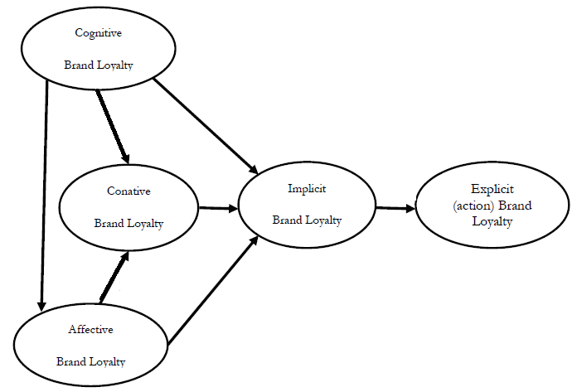
Source: Extending the four-stage brand loyalty framework in African Telecoms, 2016, P.63

Theoretical model of this study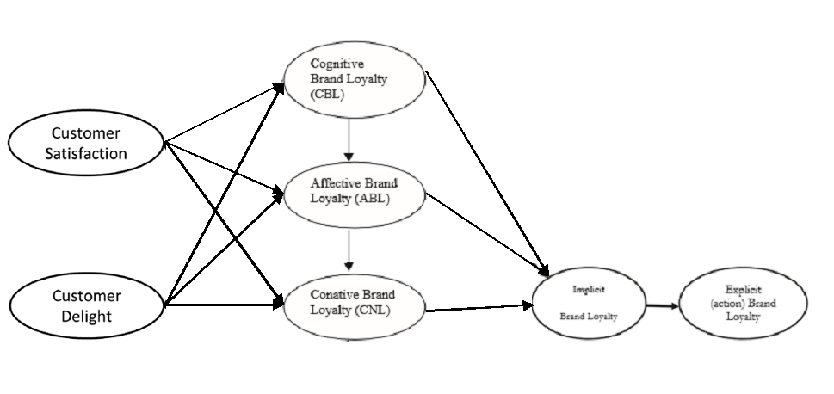

Development of a theoretical framework
- Explain the relationship of the above factors
- How to affect the Brand loyalty
- The final outcome, Brand Loyalty and explain

Key Concept
- Brand loyalty
- Factors
- Customer Satisfaction
- Customer Delight
- Cognitive Brand Loyalty
- Conative Brand Loyalty
- Affective Brand Loyalty
- Implicit Brand Loyalty
- Explicit (Action) Brand Loyalty

Best Practice
- Hospitality industry brands that success to apply this theory on their brand building
- What they do to enhance the brand loyalty

Conclusion
Summary
Important factors to consider in developing a brand loyalty
(Based on the best practice)

Limitation and further research
Based on the sourcing/ reference

